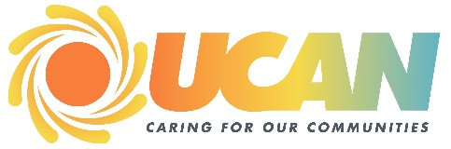**Agenda**

**United Community Action Network Board of Directors**

**Wednesday, September 25, 2024 4:00pm**

**Microsoft Teams Meeting / In Person, Grants Pass Office**

Meeting ID: 259 703 507 293

Passcode: eTHdP6

1. Call to Order, Attendance and Introductions
2. Treasurer’s Report **Tom Kress**
3. Business
   1. Adjustments to Agenda
   2. Consent Agenda
4. Approval of August 28, 2024 Board Meeting Minutes
   1. New Business
5. EHS CLASS Outcomes – Summer ’24 **Shawn Massingale (Action Needed)**
6. FY ’25 ACF Grant Update **Shawn Massingale (Action Needed)**
7. EHS Children’s Summer Outcomes **Shawn Massingale (Action Needed)**
8. Strategic Plan Update **Shaun Pritchard**
9. Determination of MeetingLocations **Steve Loosley**
   1. Head Start Policy Council Report **Rebekah Anglin-Martin**
   2. Board Training
   3. Previous Business Items
   4. Executive Director’s Report **Shaun Pritchard**
   5. Other Business Items
   6. Executive Session

*Please remember that all matters discussed in the executive session are confidential and not to be reported to or discussed with anyone not in attendance at the meeting. The Chair will brief directors who are unable to attend the executive session. Please return all materials distributed during the executive session to the Chair.*

1. Adjournment
2. Next Meeting – October 23, 2024

**UCAN Mission Statement**

Creating solutions to poverty Improving lives in our community

Core Values: Respect, Dignity, Compassion, and Equity/ Accountability/ Making a Positive Difference/ Quality and

Excellence/ Partnering/ Courage/ Honesty and Integrity

The Promise of Community Action: Community Action changes people’s lives, embodies the spirit of hope, improves communities, and makes America a better place to live. We care about the entire community, and we are dedicated to helping people help themselves and each other.